2020 ANNUAL REPORT
ACMAD

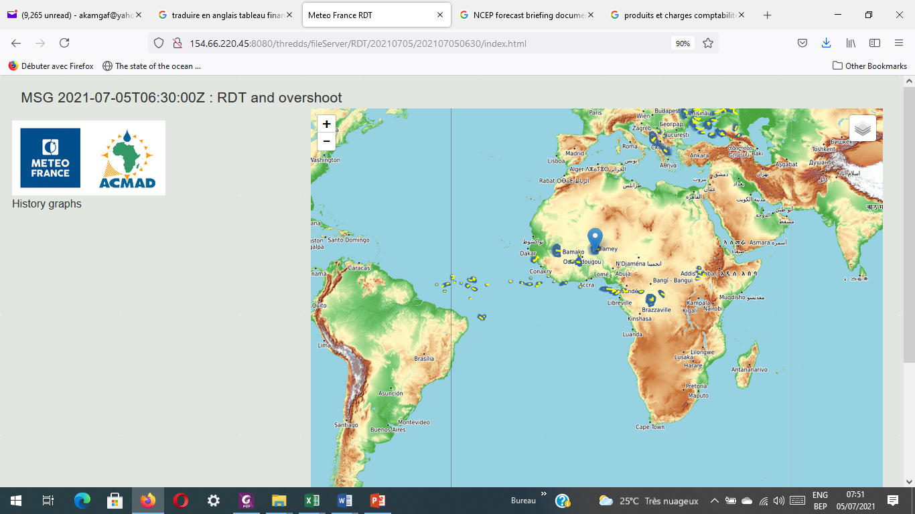

Weather Nowcasting showing Mesoscale Convective System active over Niamey-Niger with an overshooting top on July 05, 2021 morning time. This product was operational in 2020.
http://154.66.220.45:8080/thredds/fileServer/RDT/20210705/202107050630/index.html

African Centre of Meteorological Applications for Development ACMAD, 2020

Editorial correspondence and requests to publish, reproduce or translate this publication in part or in whole should be addressed to:

Secretariat,
African Centre of Meteorological Applications for Development (ACMAD)
55, Avenue des Ministères, PL6
P.O. Box 13184
Niamey-Niger
Email: dgacmad@acmad.org

Table of Contents

FOREWORD 3
HIGHLIGHTS OF 2020 ACTIVITIES AND ACHIEVEMENTS 5
STATUS OF IMPLEMENTATION OF LAST BOARD MEETING RECOMMENDATIONS AND RESOLUTIONS 7
I. CAPACITY DEVELOPMENT 8
II. PARTNERSHIPS AND RESOURCES MOBILIZATION 9
III. QUALITY SERVICES 10
IV. ACCESS TO DATA AND STRENGTHENING OF RESEARCH 11
V. GOVERNANCE AND MANAGEMENT 12

FOREWORD

In 2020, a hyperactive African summer monsoon and Tropical North Atlantic cyclone season where major significant events that impacted Africa. The associated losses and damages including up to four hundred thousand of affected people in Niger alone provided other evidences of negative impacts on communalities and population lives and livelihoods.
The period saw considerable progress in implementing the 2020-2023 strategic plan approved in 2019. This plan includes support to capacity building for NMHSs and Regional Centres, provision of quality weather and climate services, better access to data and strengthening of research, modernization of the governance and management of the centre.

Following the adoption of the strategic plan in 2019, an operating plan and a budget followed in early 2020. The African Union Specialized Technical Committee on Agriculture, rural economy, environment and water held a session which raise awareness of ministers on impacts of COVID 19 on the meteorology sector and provided policy guidance with weather, water, climate observing system sustainability, data collection and exchange, development and provision of services with emphasis on applications for disaster risk management and climate change adaptation as priorities to be supported by countries and development partners.

This annual report covers the period from January to December 2020. It contains status of implementation of the ACMAD’s Board meeting resolutions and recommendations with a summary on achievements during the year supporting Sustainable Development Goals and Agenda 2063.

(A. Kamga Foamouhoue)
Director General

An African continent where all nations are benefiting from a world class operational continental meteorological center to become resilient to extremes events and empowered to support their sustainable development with better meteorological services
(ACMAD Vision 2030)

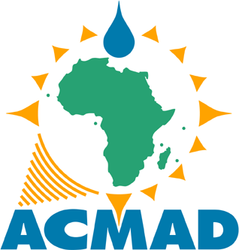

HIGHLIGHTS OF 2020 ACTIVITIES AND ACHIEVEMENTS

ACMAD implemented activities of 2020 in the process of bringing about its vision to become a world class operational continental weather and climate Centre at the hearth of Africa supporting African countries to be well resilient to extremes with increased ability to adapt to climate change impacts.

This period saw progress with approval and initial implementation of the operating plan on capacity building for NMHSs and regional centres, quality continental weather and climate services delivery, access to data, enhancement of forecasting research, improvement of governance and management of ACMAD.

The Directorate General devoted time to organize, lead, direct and guide staff towards implementation of planned activities including projects for 2020. Technical supervision for new tools and products development, automation and quality management of ACMAD’s methods, tools and products was prioritized:

- To strengthen capacity of NMHSs and Regional Centres, ACMAD focused on training programme and material development, organizing and coordinating training events (mostly online), lecturing and mentoring during and after training events.

Training programme and material development for nowcasting, synoptic forecasting, climate monitoring, sub seasonal and seasonal forecasting, climate indices for the agriculture calendar update and climate change detection and scenario production. This material is progressively uploaded on the ACMAD THREDDS data server and the cloud (i.e CLIMTAG).

A pilot combination of online workshops and face to face training at national level was organized in Burundi. This example demonstrated a country focused, result based and value chain approach for ACMAD action taking shape and supporting WMO efforts in Africa.

Online Regional Climate Outlooks were organized and coordinated for PRESASS/ECOWAS, PRESAC/ECCAS, SWIOCOF/IOC and PRESAGG for Gulf of Guinea countries, MEDCOF/PRESANORD/UMA, GHACOF/IGAD and SARCOF/SADC.

-As support to quality weather and climate services delivery, ACMAD operated the WMO Regional Climate Centre for Africa with continental products for climate data, monitoring, long range forecasting and training functions provided. This RCC operations include the RCOFs mentioned above as part of the operational collaboration with Regional Centres and related Regional Economic Communities (RECs) across Africa. The state of climate report for Africa was prepared and published with the WMO.

-To improve access to data, ACMAD through the SAWIDRA project completed procurement, installation and test of 4 Regional Advanced Retransmission System Stations completing the WMO Global Digital Broadcast Network for Low Earth Orbiting Satellite data. ACMAD was reconnected to the WMO/GTS through the Niamey airport Regional Telecommunication Hub. These achievements contribute to WMO space programme and WMO/WIS

The continental synoptic stations database on climsoft has been regularly updated, PUMA reception station for data disseminated via EUMETCAST is operational, international archives and the four RARS are providing additional data for ACMAD’s activities.

STATUS OF IMPLEMENTATION OF LAST BOARD MEETING RECOMMENDATIONS AND RESOLUTIONS

RECOMMENDATIONS | STATUS OF IMPLEMENTATION
1. ACMAD to convene a meeting with AU, UNECA and WMO/AMCOMET to review the relationship agreement with AUC and submit related document to the upcoming AU/STC bureau meeting. | ACMAD held a meeting with the UNECA bureau in West Africa following the January 2020 Board session. The Niamey bureau submitted the recommendation to the headquarters in Addis Ababa and informed ACMAD that the relationship agreement is under study by the Climate Change, Environment and Natural Resources division of UNECA.
2. SACOM to provide a draft on ACMAD policy guidelines on continuous professional training, mentorship and internship for quality services, partnerships and networking | ACMAD established a framework for mentoring with EUMETSAT, on internships and mentoring with University of Reading and the African Institute for Mathematical Science, on the job training with VITO, training material development with UK Met Office through SWIFT, FOCUS-Africa project and Copernicus C3S through Wageningen University and ECMWF.
3. ACMAD should use the existing platforms like SARCOF, GHACOF and other fora to raise awareness on its products for its visibility | In 2020, ACMAD organized the climate part of the RCOF for ECOWAS region, the PRESAC with ECCAS, SWIOCOF with IOC, trained experts and contributed with continental climate outlooks products to MEDCOF, SARCOF, SWIOCOF and GHACOF. Sessions on development of Climate services to update and/or adjust agriculture calendars for building climate resilience were organized by ACMAD at all RCOFs.
4. ACMAD to use WMO template, guides and manuals | As WMO regional Climate Centre for Africa, ACMAD in 2020 applied guide for objective seasonal forecasting, the guide for interpretation of probabilistic forecasts and forecaster handbook. The planning, reporting frameworks and templates of WMO are progressively being used as references. ACMAD is the WMO RCC and is looking for demonstrating capacity to become a continental severe weather RSMC therefore applying WMO guides on all weather and climate products provision. The WMO WWRP/ Tropical Meteorology Research working group and the WMO Standing Committee on Data Processing for Earth System Modeling and Prediction are two WMO programmes developing, updating manuals in which ACMAD has become member.
5. ACMAD to synergize with WMO regional Training Centres and OSS based in Tunis | In the framework of the SWIFT project training and legacy work packages, ACMAD, WMO RTCs in Niamey/Nairobi and WMO global campus initiative are collaborating on development of new chapters in forecaster handbook and its extension over East Africa, An MOU is being proposed with WMO/RA II Regional training Centre at the Meteorological Training Institute of the Indian Department of Meteorology
6. ACMAD to contribute to the state of environment report of UNEP | ACMAD and UNEP under the coordination of WMO contributed to the 2019 state of climate for Africa. ACMAD has included UNEP in the list of contributors to the upcoming 2020 state of Africa’s climate report
7. ACMAD to prepare a policy document stimulating member states to invest in NMHSs and supporting their evolution | The board to discuss and amend the draft policy document and provide guidance for its preparation
8. ACMAD to add a summary section and a table of contents, the major thematic areas of ACMAD actions, a description of units of activities in the institutional aspects chapter of the manual and develop a similar manual for the operations of technical departments | Additions made in the manual. The development of procedure manuals for technical department operations is ongoing with service/product catalogues, scripts for generation each product collected. These elements are being completed for new products designed in 2020 (i.e., for the 2020 annual state of climate).

I. CAPACITY DEVELOPMENT

To strengthen capacity of NMHSs and Regional Centres, ACMAD focuses on training programme and material development, organizing and coordinating training events (mostly online), lecturing and mentoring during and after training events.

Training programme and material development for nowcasting, synoptic forecasting, climate monitoring, sub seasonal and seasonal forecasting, climate indices for the agriculture calendar update and climate change detection and scenario production. This material is progressively uploaded on the ACMAD THREDDS data server and the cloud (i.e CLIMTAG).

Coordination and organization of training events hands on, workshops and as part of Regional Climate Outlook Fora in West, Central and Southern Africa as well as the Gulf of Guinea. A pilot combination of online workshops and face to face training at national level on nowcasting, synoptic forecasting, sub seasonal and seasonal forecasting, interpretation of probabilistic forecasts, outlooks, advisories, watches and warnings delivery was organized in Burundi. This example is expected to be upscaled in other countries in the years to come facilitating and supporting competency development and better performance of NMHSs. The country focused, result based and full value chain approach for ACMAD action is therefore taking shape and supporting WMO efforts in Africa.

Online Regional Climate Outlooks were organized and coordinated for PRESASS/ECOWAS, PRESAC/ECCAS, SWIOCOF/IOC and PRESAGG for Gulf of Guinea countries. Lectures and mentoring activities during and after workshops and fora across the continent during the above mentioned RCOFs, GHACOF and SARCOF supported national level capacity building with special emphasis on development of climate information on onset and other parameters of the agriculture calendar.

II. PARTNERSHIPS AND RESOURCES MOBILIZATION

- partnerships, collaboration, commitment and networking letters and agreements discussed or/and formalized with Pennsylvania state University in the US on research and development of new products and training materials, the Training institute of the Indian Meteorological Department on internships and knowledge exchange on tropical meteorology, VITO for climate information systems for agriculture calendar updates and local governments climate resilient development planning, AUC for implementation of Climate services at continental level in Africa, CIMA foundation for hydrological monitoring and floods forecasting in Burundi and development of continental disaster resilience project with emergency operations and situation room, UNDP for training for climate services providers and humanitarian actors on early warning and action in Burundi, AIMS and University of Reading on data management and products generation with climsoft, R-INSTAT tools development and use in Africa, EUMETSAT for mentoring interns for development of training materials and new products from satellite data ( i.e MTG, AMSAF) supporting monitoring, forecasting, outlooks, advisories, watches and warning;
- Resource mobilization with proposals and agreements providing financial support and technical partnership (FOCUS-Africa with EU/H2020, uCLIP with the Belgian development agency, KIMPALA with VITO funded by the Flemish government in Belgium, SWIFT with University of Leeds funded by UK Government Global Challenges Research Fund, Agraclim Service with VITO funded by ECMWF through EU funded Copernicus programme, SAWIDRA for weather information for disaster resilience in Africa and ISACIP phase 2 to further strengthen climate institutions in Africa funded by African development Bank Regional window, Continental Climate change assessment with Norwegian Refugee Council, Intra ACP GFCS funded by the European Development Fund… );
- Report for 2020 and plan for 2021 are presented in this session. Regular progress reports for projects have been provided to contracting authorities and donors, projects formulation and their implementation were completed and some agreements signed (KIMPALA, Agraclim, FOCUS, WMO guide for Seasonal forecasting, uCLIP with VITO funded by Belgian Development cooperation agency, Intra ACP GCFS Continental project, Intra ACP GFCS Regional project for Central Africa);
- Communication, visibility and outreach efforts featured ACMAD attending RCOFs, WMO Climate Coordination Panel and Standing Committee on Earth System Modeling and prediction meetings, steering and kick off meetings of projects, online events for training, projects formulation and coordination meetings, High level events including AU Specialized Technical committees and related sub committees sessions, state of Africa Climate for 2019 launch, technical and scientific meetings for collaboration.
- A feedback is expected from UNECA on the proposal for a meeting with WMO and AUC on the formal agreement on ACMAD as the technical arm of AUC and weather and climate matters. A proposal was made through the WMO sub-regional Office for West , Central and North Africa for having the formal agreement on ACMAD as technical arm of AUC and the start of the demonstration phase for the Regional Climate Centre in Central Africa on the agenda of the meeting between WMO SG and the President of AU. A review of the ACMAD headquarter agreement is being discussed to adapt its relevant provisions to new developments notably in taxation with community levies.

III. QUALITY SERVICES

As support to quality weather and climate services delivery, ACMAD operated the WMO Regional Climate Centre for Africa with continental products for climate data, monitoring, long range forecasting and training functions provided. Contributions with continental scale outlooks were provided for all RCOFs PRESASS/ECOWAS, PRESAC/ECCAS, PRESAGG for the Gulf of Guinea, SWIOCOF/IOC, GHACOF/IGAD, SARCOF/SADC and MEDCOF/PRESANORD/AMU.

Nowcasting products (Nowcasting SAF in particular), global and regional analyses and Numerical Weather Prediction deterministic and probabilistic derived products, outlooks, advisories and watches were generated and disseminated. Three levels of deliverables were provided:
- technical notes to guide NMHSs monitoring and forecasting briefings or operations;
- reports and bulletins for awareness raising on upcoming hazards for the general public and experts in agriculture, water, Disaster risk Management, health and other relevant sectors;
- summaries and short statements for planners and policy makers.

The State of climate of Africa for 2019, the provisional state of Africa’s climate for 2020, RCOFs statements, outlooks, advisories and watches for high impact and severe weather events in 2020 (floods, disruptions on the African monsoon onset, high temperatures, droughts, south west Indian ocean cyclones...) were published through emails and website.

IV. ACCESS TO DATA AND STRENGTHENING OF RESEARCH

To improve access to data, ACMAD through the SAWIDRA project completed procurement, installation and test of 4 Regional Advanced Retransmission System Stations completing the WMO Global Digital Broadcast Network for Low Earth Orbiting Satellite data. This effort contributes to WMO space programme as well as its Information System. ACMAD was reconnected to the WMO/GTS through the Niamey airport hub. Connection to WIS through the Global Information System Centre in Casablanca is planned for 2021. A plan is available to facilitate exchange of ACMAD products through WIS and prepare for MTG and SG EPS data access. Monitoring impacts of COVID 19 on the African synoptic observing network was presented during relevant meetings. The intra ACP GFCS and the emerging resource mobilization effort for implementation of the Abidjan declaration are being followed by ACMAD in the partnership with EUMETSAT under a Joint Working Group established by AUC.

The continental synoptic stations database on climsoft has been regularly updated, PUMA reception station for data disseminated via EUMETCAST is operational, international archives (Copernicus Climate Data Store, ECMWF data archive, NOAA/NOMAD data Server, IRI data Library …..) and the four RARS are providing additional data for ACMAD’s activities. ACMAD participated to WMO/RA I RAIDEG group and contributed to discussions on products to be disseminated through EUMETCAST with the MTG and AMSAF.
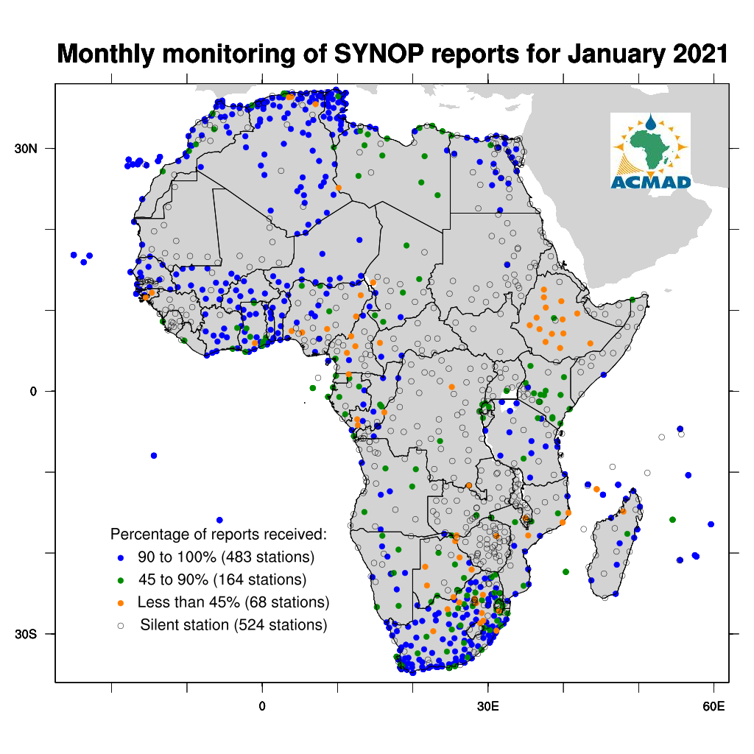
Figure 1: Status of Synoptic stations in Africa. Rehabilitation of silent stations is a priority for investment with the Systematic Observing Financing Facility (SOFF).

To enhance forecasting research networks in Africa, ACMAD is implementing SWIFT and FOCUS Africa projects and other initiatives limited in time and scope. Research on nowcasting, synoptic, sub seasonal and seasonal forecasting supported, operational procedures and forecaster handbook preparation, new products development for technical notes and upgrade or extension of training materials using available advances in science and technology. ACMAD Forecast demonstration and SWIFT testbeds have experimented the new products and their detailed design will support 2021 demonstrations and testbeds. Operational procedures to deliver products and services in the framework of quality management were initiated on state of climate, nowcasting, synoptic and seasonal forecasting. Catalogue of products and services have been updated.
FOCUS Africa project work plan is completed with training plan, material development and organization of training and stakeholder events for climate services delivery and use. Papers, abstracts and presentations were prepared for scientific and technical meetings and events including the American Meteorological Society Conference on hurricanes and tropical meteorology, the WMO Standing Committee on Earth System Modeling and Prediction and the WMO Climate Coordination panel reporting to its Technical Coordination Committee and Executive Council.
An online platform for generation of agro climate services and update or upgrade of agriculture calendars in Africa was developed with VITO (A Flemish Institute for technological research for a cleaner and sustainable world). Demonstration and training for the use of this platform have started with 2020 RCOFs and is expected to continue for the upcoming years involving the NMHSs, ministries of agriculture, Food and Agriculture organization.
An online information system with specific tailored weather, water and climate products for Burundi was developed, training material for its use prepared. A similar effort is expected for the upcoming years in other countries.

V. GOVERNANCE AND MANAGEMENT
The governance and management modernization of the centre aspect featured:
- the adoption of the procedure manual and starting of its application in 2020 (i.e., provision account for long term benefits in the chart of accounts);
- the identification of projects and permanent staff posts differences in costing and proposal for harmonization (Agenda item 4);
- Health insurance provided to ACMAD staff in 2020;
- the auditor for ISACIP under recruitment with the call for expression of Interest finalized with the AfDB;
- the audits for SAWIDRA up to date;
- the audits for ACMAD up to date, the auditor recommendations will be discussed to find opportunities for implementation;
- Following asset inventory, a list of fully amortized or depreciated assets to be disposed of is available.
The budgeted resources execution rate for 2020 was 75% and the budgeted expenditure execution rate was 59,4%.

Description | 2020 Budget resources in Dollars | 2020 budget in CFA francs | 2020 actual resources | Budget execution rate | budget lines contribution rates
regular resources | 1 277 896 | 681 974 992 | 458 748 760 | 67% | 20%
countries contributions | 49 500 | 26 416 665 | 26 730 000 | 101% | 1%
Countries contributions ( no ratification of ACMAD's constitution) | - | - | - | 0% | 0%
Grants and aid | 1 227 896 | 655 291 492 | 432 018 760 | 66% | 19%
extraordinary resources | 4 512 078 | 2 407 960 726 | 1 843 333 205 | 77% | 80%
legs and gifts | 3 599 192 | 1 920 780 820 | 1 371 485 279 | 71% | 60%
income from financial activities |  | - | - | 0% | 0%
books sold and other services |  | - | 38 020 | 0 | 0%
furniture disposal |  | - | - | 0% | 0%
plans, equipment and property disposal |  | - | - | 0% | 0%
rent of vehicles, apartments, rooms, translation booth | 43 098 | 23 000 000 | 7 630 000 | 33% | 0%
projects overheads | - |  | 0 | 0% | 0%
opening cash balance | 869 788 | 464 179 906 | 464 179 906 | 100% | 20%
TOTAL | 5 789 475 | 3 089 668 883 | 2 302 081 965 | 75% | 100%

Table 1: 2020 budget resources execution (1% of the 2020 revenue from countries contributions, this rate averaged over the past 5 years is 5%)

Description | 2020 expenditure budget (cfa) | 2020 actual expenditure (cfa) | Execution rate
Operating expenses | 412673748 | 162098897 | 39,28%
Personnel | 152896417 | 96806573 | 63,32%
training | 66777331 | 25911728,96 | 38,80%
Consumables, furniture and other services | 193000000 | 39380595 | 20,40%
taxes, bank charges, unforeseen expenses |  |  | 0,00%
depreciation and provisions |  |  | 0,00%
Research and development expenses | 2647261970 | 1673154039 | 63,20%
ISACIP | 0 | 0 | 0,00%
MESA | 0 | 0 | 0,00%
VITO/CLIMTAG | 33747137 | 7499359 | 22,22%
VITO/KIMPALA | 0 | 0 | 0,00%
OMM guide PRESAC | 5967129 | 5967129 | 100,00%
SWIFT | 105958809 | 74282069 | 70,10%
FOCUS | 92175000 | 65787023 | 71,37%
UNDP Burundi | 161469000 | 146230989 | 90,56%
SAWIDRA | 1920780820 | 1371485279 | 71,40%
IMPALA | 1952190 | 1902190 | 97,44%
GFCS | 325211884 | 0 | 0,00%
Investment expenses | 30000000 | 859200 | 2,86%
plants property and equipment | 26000000 | 0 | 0,00%
furniture | 2000000 | 859200 | 42,96%
Computer hardware and software | 2000000 |  | 0,00%
reimbursement of debts | 0 | 0 | 0,00%
TOTAL | 3089935718 | 1836112136 | 59,42%

Table 2: 2020 expenditure budget execution

