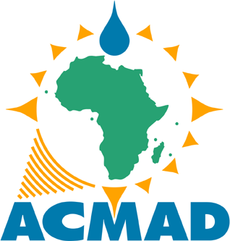  CENTRE AFRICAIN POUR  LES APPLICATIONS DE LA METEOROLOGIE  AU DEVELOPPEMENT |  |  | AFRICAN CENTRE  OF METEOROLOGICAL APPLICATIONS  FOR DEVELOPMENT
Institution Africaine parrainée par la CEA et l’OMM |  | African Institution under the aegis of UNECA and WMO
ANDRE KAMGA FOAMOUHOUE
DIRECTOR GENERAL OF ACMAD ( African Centre of Meteorological Applications for Development)
His expertise is on Predictability of Weather and Climate with a long standing track record providing operational, research, management and leadership knowledge on meteorology. Dr Kamga Foamouhoue defended a doctorate thesis in 1999 on the quality of ECMWF operational Medium Range Forecasts over Tropical Africa. He led the evaluation of NCAR CSM projections over West Africa
He is well known in the meteorological community for his key role in the demonstration phase leading to the designation in 2015 of ACMAD as a full-fledged multifunctional WMO Regional Climate Centre for all Africa which was the first in Africa.
His career has taken him to NOAA/NCEP Climate Prediction Center as a visiting scientist at the African Desk, UK Met Office Hadley Centre for Regional Climate Modeling with PRECIS Regional Climate Model, WMO as Scientific Officer (short term) at the Climate Prediction and Adaption Branch of the Climate and Water Department, European Centre for Medium Range Weather Forecast as the EU funded African Monsoon Multidisciplinary Analysis (AMMA) project Work Package Leader dealing with Forecast Demonstrations and Operational Forecasting Support for the Special Observing Period(SOP) of AMMA during the 2006 summer monsoon.
He was co-chair of the WMO's World Weather Research Programme /THORPEX Africa Regional Committee and spearheaded the development of THORPEX Africa science and implementation plans.

Prior to joining his current position, he was Chief of Climate and Environment Department of ACMAD. He is also a member of the American Meteorological Society as well as the WMO International Coordination Team for the Climate Service Information System of the Global Framework for Climate Services(GFCS).
ACMAD is currently working to fill capacity gaps for quality, need based, science based weather and climate services for building resilience and adaptation to climate change in Africa. A strong partnership with the African Union Commission, the Africa Risk Capacity agency, the disaster risk reduction platforms and working groups, the regional consultations for disaster management under the leadership of RECs and UNOCHA is under development to better operationalize Multi hazards Early warning systems to reduce losses and damages in Africa.

