CENTRE AFRICAIN POUR LES APPLICATIONS  DE LA METEOROLOGIE AU DEVELOPPEMENT | 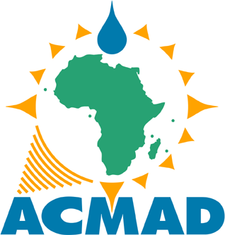 | AFRICAN CENTRE OF METEOROLOGICAL APPLICATIONS FOR DEVELOPMENT

Nº /ACMAD/DG/ | Niamey, February XX, 2019

To Whom It May Concern:

This is to confirm that Dr. Benjamin Lantei Lamptey worked in ACMAD from September 2013 to December 2018. He joined ACMAD as the Deputy Director General (DDG) and became the Acting Director General, cumulatively with his DDG position from 1st January 2017 to 31st December 2018.

As DDG he had oversight responsibility over technical and scientific activities. This included supervision of the Heads of Departments as well as Project Coordinators. Additionally, Dr. Lamptey was the Project Coordinator of the African Development Bank (AfDB) funded Institutional Support for African Climate Institutions Project (ISACIP) from 2013 to December 2016 when the project ended. ISACIP a multi-institutional project, comprised four climate institutions: ACMAD and AGRHYMET in Niger, ICPAC in Kenya and SADC-CSC in Botswana. The project activities included Implementation of weather and climatic information systems; seasonal climate forecasts; Downscaling global climate data & scenarios; assessment of climatic impacts among others.

Dr. Lamptey also coordinated the European Union funded Monitoring of Environment and Security in Africa (MESA) project from the finalizing of the grant proposal (September 2013) through its approval until the end of the inception period of the project (December 2014). The ACMAD MESA THEMA was “Climate Services for Disaster Risk Reduction.” He also coordinated in ACMAD the UK Department for International Development (DFID) funded Future Climate For Africa (FCFA) Project – UK Meteorological Office global consortium on Improving Modeled Processes for African Climate (IMPALA) from 2015 until he left in December 2018. He was also the African Principal Investigator on the Research Councils of the United Kingdom (RCUK)/Global Challenges Research Fund (GCRF) funded African Science for Weather Information and Forecasting Techniques (SWIFT) Project. He was involved in the preparation of the project from 2016 but the implementation of the project started on 1st October 2017.

Dr. Lamptey was the ACMAD focal point for the West Africa Hub of the AGRHYMET led Consortium of the NASA-USAID funded SERVIR Project - Environmental Monitoring from Space to Village using Earth Observation and geospatial technologies (2016 to 2018)

Dr. Lamptey also wrote proposals during his time at ACMAD. For instance,
- He wrote the European Union funded (through the African Development Bank) Satellite and Weather Information for Disaster Resilience in Africa (SAWIDRA) Project (A Continental Numerical Modeling Project) and oversaw its implementation (as DDG) until he left in December 2018.
- He wrote the EU funded ACMAD Intra ACP-EU Global Framework for Climate Services Project proposal: (Continental) Climate Services and Related Applications Programme. The project is to support the implementation of the GFCS in Africa.
- He completed the draft proposal of the Africa Hydromet (continental project) project awaiting directives from African Development Bank (as at December 31, 2018).

Dr. Lamptey also started an In-house capacity development program in ACMAD to improve efficiency in operations (Linux OS, Shell scripting, etc.) and analysis and visualization of meteorological data in 2015.

Yours Sincerely,

Andre Kamga Foamouhoue
Director General

