CENTRE AFRICAIN POUR LES APPLICATIONS  DE LA METEOROLOGIE AU DEVELOPPEMENT |  |  | AFRICAN CENTRE OF METEOROLOGICAL  APPLICATIONS FOR DEVELOPMENT
Institution Africaine parrainée par la CEA et l’OMM |  | African Institution under the aegis of UNECA and WMO

 | REGIONAL CLIMATE OUTLOOK FORUM  PRESASS-03  Ouagadougou, Burkina-Faso 16th – 20th May, 2016
THEME: “Seasonal forecast: A Climate Service to build resilience and reduce climate risks in the Sudano-Sahelian region of Africa”

SEASONAL CLIMATE OUTLOOK BULLETIN
VALID FOR JUNE –JULY-AUGUST AND JULY-AUGUST-SEPTEMBER, 2016
OVER THE SOUDANO-SAHELIAN REGION OF AFRICA,
(Ouagadougou, 20th MAY, 2016)

Produced by
The African Centre of Meteorological Applications for development (ACMAD) in collaboration with National Meteorological and Hydrological Services of West Africa, Cameroon, Chad and CAR with support of WMO designated Global Producing Centers for Long Range Forecasts and the International Research Institute for Climate & Society at Columbia University in New-York USA.

This is a product of the Institutional Support to MESA Project funded by European Union

EXECUTIVE SUMMARY

Given the current Seas Surface and Sub-surface Temperature patterns and trends, models outputs and expert judgment, the precipitation outlooks for June-July-August and July-August-September 2016 are as follows:

- Near to below average precipitation is very likely over coastal parts of Senegal, Gambia, and Guinea-Bissau from June to August 2016;

- Below average precipitation is very likely along the coast from Sierra-Leone to southwestern Nigeria from June to September 2016;

- Near to above average precipitation is expected over most of the central and parts of western Sahel in eastern Senegal, southern Mauritania, much of Burkina Faso, southern Niger and northern Ghana, Benin, Togo, Nigeria, Cameroon and central Chad from June to August, 2016;

- Near to above average precipitation is expected over most of the central Sahel in eastern Senegal, southeastern Mauritania, much of Burkina Faso, southwestern Niger, northern Togo and Benin, northwestern Nigeria from July to September, 2016;

- Above average precipitation is very likely over eastern parts of the Sahel in southeastern Niger, northeastern Nigeria, central Chad and northeastern CAR from July to September, 2016;

- Near average precipitation is very likely for the remaining part of the region;

- Irregular distribution of precipitation during the season is very likely with dry spells, abnormal onset and/or cessation particularly over most of Sahel region;

- Disaster Risk managers over the Sahel region are advised to prepare for precipitation deficits.

Countries and regional organizations are advised to strengthen capacity for climate monitoring, update of seasonal outlooks and sub-seasonal forecasting for better management of expected risks related to local precipitation deficits and irregular distribution of precipitation during the season. Agriculture extension workers and water managers will be important contributors to mitigation of precipitation deficits and related risk by collecting climate information from climate service providers and deriving relevant impacts and advices for users.

RECENT CLIMATE CONDITIONS AND OUTLOOK

- STATE OF THE TROPICAL OCEANS AND TRENDS

- From September to December, 2015 strong El Niño conditions were observed in the ENSO region. Since January, 2016, a decrease in ENSO intensity was noted. Most model outputs and expert assessments suggest a persistence of this decreasing trend leading to ENSO neutral conditions by May or June, 2016.

- The tropical north Atlantic SSTs were above average from January to March, 2016. From April to early May, 2016 this pattern has evolved towards neutral condition with a cold tongue. The persistence of this pattern is more likely during the coming few months.

- The equatorial Atlantic was above average from January to April, 2016. This pattern is expected to evolve towards neutral condition during the coming months.

- The tropical south Atlantic SSTs have been above average during the past months. Most models and expert assessments are favorable for an evolution towards near average SSTs during coming months.

- The Mediterranean Sea SSTs have been near to above average during past few months.
Most models outputs and expert assessments are favorable for persistence of these
conditions during the coming months.

- The equatorial and southern tropical Indian Ocean SSTs have been above average during
the past few months. Most models and expert assessments are suggesting a persistence of
this pattern during the coming three to four months.

- PRECIPITATION OUTLOOK

Given these SST anomalies, sub-surface temperature patterns and trends, knowledge and understanding of seasonal climate variability over the Sudano-Sahelian region of Africa, and available long range forecasts products, the following outlooks are provided for June-July-August (JJA) and July-August-September (JAS), 2016 seasons in the region (see figures 1 and 2 below):

- Near to below average precipitation is very likely over coastal parts of Senegal, Gambia, and Guinea-Bissau from June to August, 2016;

- Below average precipitation is very likely along the coast from Sierra-Leone to southwestern Nigeria from June to September 2016;

- Near to above average precipitation is expected over most of the central and parts of western Sahel in eastern Senegal, southern Mauritania, much of Burkina Faso, southern Niger and northern Ghana, Benin, Togo, Nigeria, Cameroon and central of Chad from June to August, 2016;

- Near to above average precipitation is expected over most of the central Sahel in eastern Senegal, southeastern Mauritania, much of Burkina Faso, southwestern Niger, northern Togo and Benin, northwestern Nigeria from July to September, 2016;

- Above average precipitation is very likely over eastern parts of the Sahel in southeastern Niger, northeastern Nigeria, central Chad and northeastern CAR from July to September, 2016;

- Near average precipitation is very likely for the remaining part of the region;

- Early to normal start of precipitation with dry spells during the season is very likely over central and southeastern Sahel, late to early cessation is very likely over most of Sahel region and north of Gulf of Guinea.

III- AGRO-CLIMATIC CHARACTERISTIC OF PRECIPITATION SEASON

- Late to normal onset of the precipitation season is very likely over central south, northern and eastern Sahel.

- Normal to late start of the precipitation season is very likely over southwestern of the Sahel and northern Gulf of Guinea.

- Early to normal start of the precipitation season is very likely over central and southeastern Sahel.

- Late cessation is very likely over most of the Sahel and northern Gulf of Guinea.
IV-ADVICES

- For farmers
- In areas where it is more likely to observe cumulative below average precipitation, beginning late season dates, and longer dry spells after onset, farmers must:
- Use varieties resistant to drought and / or short cycles,
- Avoid additional inputs of fertilizer during the growing season,
- Focus on promoting the cultivation techniques of soil water conservation.

- For areas where it is more likely to observe above average with early season start dates and shorter dry spells after onset, farmers must:
- invest more in seed of improved varieties for both food crops to cash crops,
- Strengthen vigilance against weeds and pests (locusts and other insects).
- Sow early
- prioritize high land areas for planting

- For Breeders:

- In areas with a high probability of a late start of the precipitation season, consider the livestock food stock and facilitate access to the animals to the nearest water point, to bring the livestock to shelter from the effects of lack of water and to avoid conflicts between farmers and herders,

- Disaster Management Sector:

- Updating of contingency plans, intensification of advocacy and resource mobilization is required to address the impact of an extended post-2016 harvest lean season. Prepare for floods including drainage system and drug stocks.

- Health Sector

- It is advised to sensitize states on disease surveillance services and non-Governmental organization to prepare drug stocks for use in case of epidemics.

- Enforce hygiene and sanitation system, monitor malaria, cholera and preposition drugs stocks

Over Western Parts of the region and other locations where below average precipitation is very likely the following advices are provided for stakeholders:

- Prioritize low land areas for planting;

  - use water conservation techniques;

  - crop varieties resistant to precipitation deficits;

  - plan for irrigation to manage possible precipitation deficits;

  - plan an early start of transhumance;

  - prepare or rehabilitate water points for animals;

  - prepare for possible deficits in the water in reservoirs;

  - prepare for emergency assistance in case of crop failure;

  - Increase vigilance for conflicts between farmers and pastoralists.

NB: Users are strongly advised to contact National Meteorological and Hydrological Services for further expert advices and assistance.

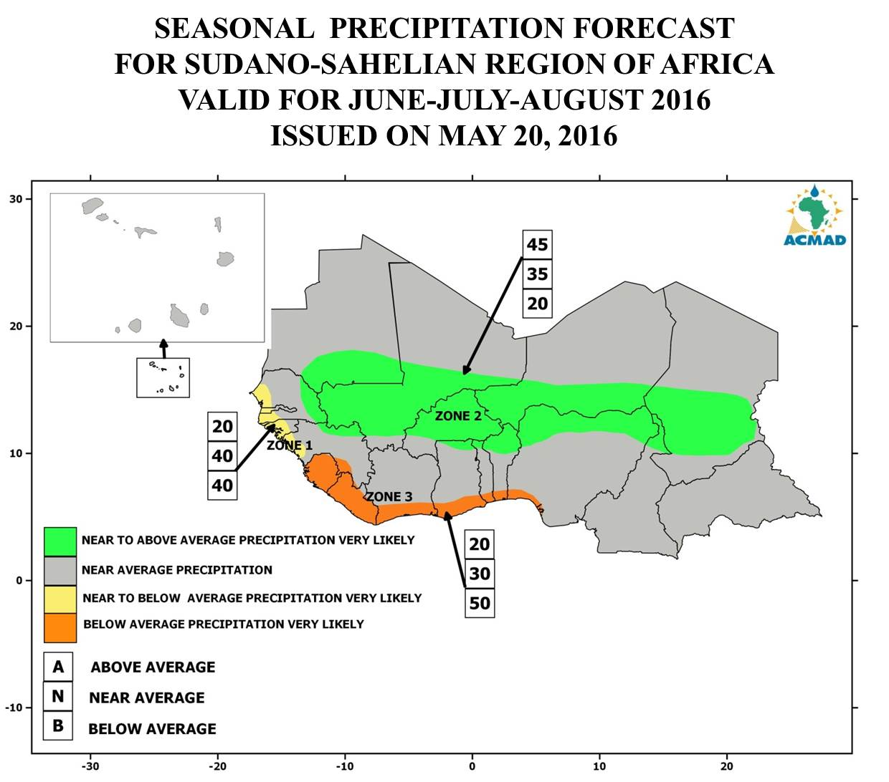

Figure 1: Seasonal forecast of precipitation for June-July-August, 2016

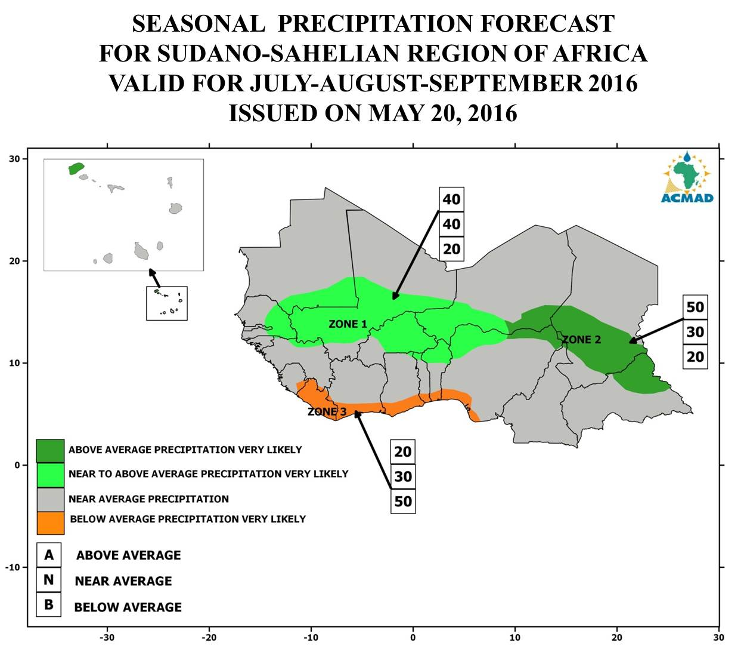
Figure 2: Seasonal forecast of Precipitation for July-August-September, 2016

This outlook is produced at the regional scale. Thus, its interpretation should be for regional use. For local and/or country adaptation and applications needs, it is highly recommended to consult the National Meteorological and Hydrological Services for local details.

